**Library Management System for Stanford**

**STAKEHOLDERS**

|  |  |
| --- | --- |
| **ACTOR** | **What he can do on the Software Created** |
| Student | * Students can access the interface from their computer or from mobile by providing Student id and password. * Students can search books, magazines, newspaper and other materials and check where it is located. * Students can check the return date of the book from the system. * Students can access free reading materials from the system. * Students can return the book at the RFID enabled book drop station anytime. * Students can get automated reminder 3 days before the return date. |
| Library Staff | * Staff can search the books by different criteria like author’s name, name of the book, publication date, edition, publisher name. * Staff can assign and maintain RFID tag. The tag will assign to – books name, author, edition, publication date and year, purchase date of the book, cost of the book. It will help to better track and update the record. * Staff can issue and re-issue of the reading materials. * At the time of issuing of the book the staff can use the RFID to capture the details of the book with students name tagged with it and date of issuance. * Staff can search different reading materials category-wise and subject-wise. * Staff will be able to keep records of different reading materials available in the library. * In case of late return staff will be able to calculate fine from the system. |
| Management | * Sponsor of the project. * Can generate report to understand the demand of books for future availability in a greater volume and vice versa. * Can decide the requirement of manpower for future and calculate cost. |

**PROBLEM DEFINITION AND SOLUTION**

1. Wastage of time maintaining manual library.
2. The number of employee to manage a manual library is high so the cost of running the library is high.
3. Fine calculation is complicated.
4. Record keeping and managing of the 4 million books in the library is very difficult.
5. There is no report generation system.
6. Student can deposit the book only in the library timing.

**Advantages of LMS**

Advantages of Library Management System:

* Reduce overheads and productivity of the library staff.
* Cost reduction.
* Improvement student engagement in the library.
* Dynamic report generation for better decision making.
* Up to date records and tracking of all the reading materials available in the library.

**EXISTING SYSTEM**

* The current process is manual. Current process incudes –

1. Keep recording of all the reading materials by the Library staff manually
2. Issue/reissue books to the students
3. Fine calculation
4. Create report periodically for the management
5. Students can return the reading materials only in library time.
6. Students cannot access any reading materials online.
7. Management cannot generate report in-demand basis and has to review the reports which were processed by the library staff periodically.

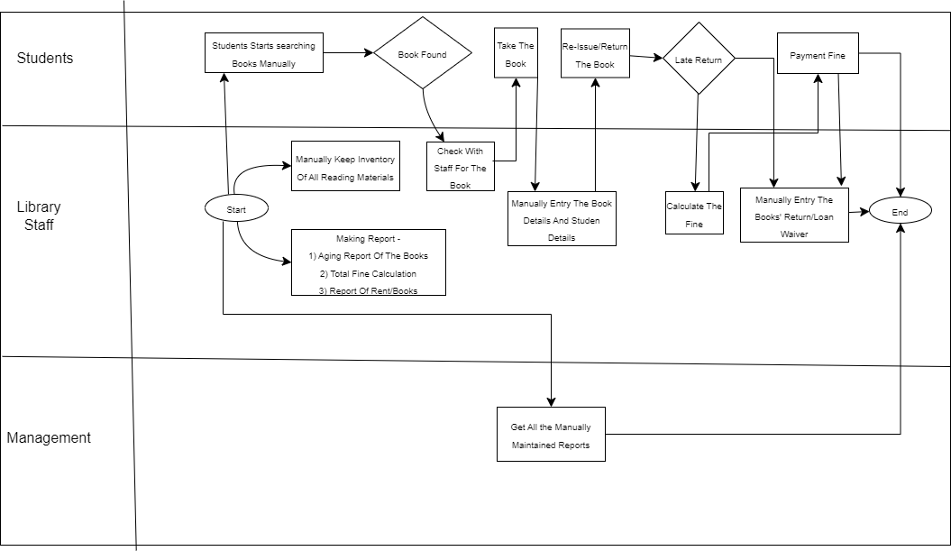

**PROPOSED SYSTEM**

What is the proposed solution or system? Mention in points how the system itself will be for the user. (Sample points given, you can add more to it)

* User friendly interface
* Better management –

1. LMS will keep track of all the reading materials like books, magazines, newspapers and journals.
2. LMS can classify the books subject-wise.
3. Library staff can search the books by their author’s name or book name.
4. Different reading materials has different issue period.
5. LMs will track issue date and return date of all the reading materials.

* Fine Calculation – LMS can calculate fine based on the issue date and return date.
* Tracking –

1. All the reading materials will have RFID tag attached with it.
2. LMS will store all information of the book like – book’s name, author’s name, edition, buying date, publication date.
3. LMS can issue any book by scanning the RFID. The students name will be tagged with book details in the time of issuance.
4. The RFID tracker will be placed at exit and they reader will track the books up to 2 meter, so there will be better theft-management.

* Better Student engagement –

1. Student can access the LMS via the web interface or mobile to check the issue date, return date.
2. Student will receive automated reminder mail before 3 days of return date.
3. They can return the book at RFID scanned enabled deposit box any time and the loan will be cancelled immediately.
4. Students can access free reading materials via online.

* Better management decision –

1. Management can check which books are rented most and based on that they can keep higher inventory of those books.
2. Number of lost books.
3. Can track age of the books so that library can maintain the new edition of the books.
4. Total number of reading materials category wise (books, journals, and magazine) and subject wise.
5. Issuance of reading materials daily/monthly/yearly basis.
6. Fine collection.

**Flowchart for LMS**

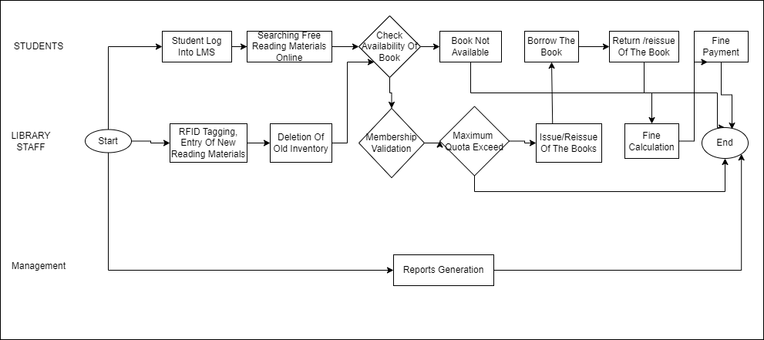

**SCOPE using Use Case Diagram (UML)**

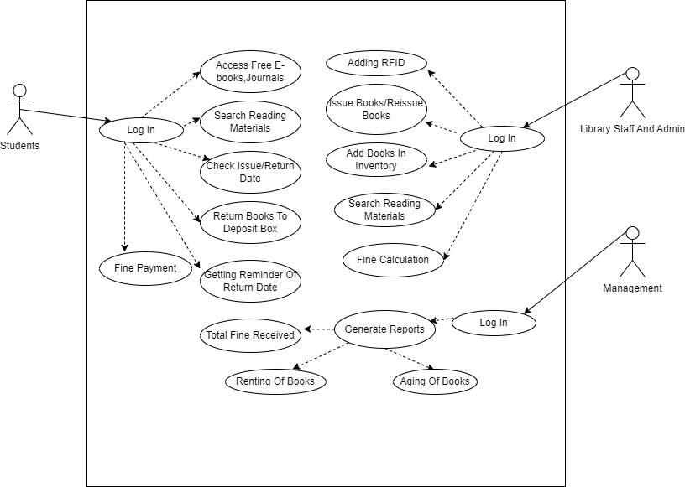

**SCOPE using Context Diagram**

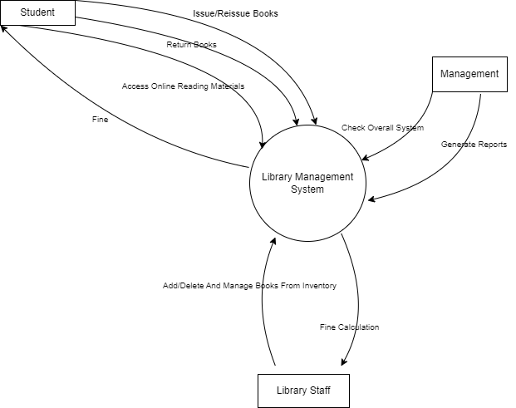

**DATA FLOW DIAGRAM**

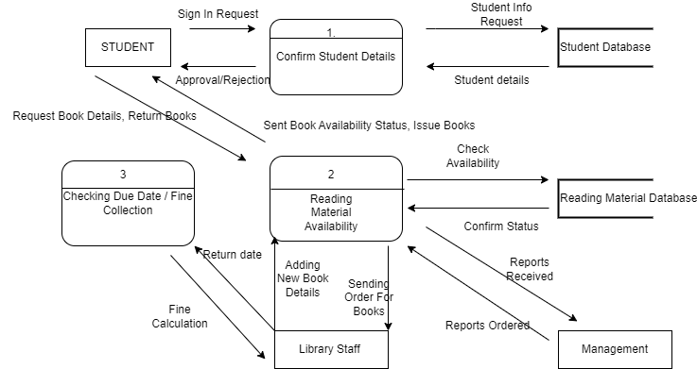

**IN SCOPE**

* Issue of the book.
* Return of the book in a RFID enabled deposit box.
* Categorizing of the reading materials.
* Access the LMS by the student and the library staff via web interface and mobile.
* Access to free e-books, journals, magazines, newspaper via online.
* Generating of different reports like – total number of books available anytime, aging of books, number of books stolen, number of damaged books, fine collection report, which books are getting rented most and least.

**OUT OF SCOPE**

* Issue of the book online.
* Online fine collection.

**Wireframes:**

Create sample wireframes for the system. Capture what screen will be show to the library employees to create records for each book and at what stage in the system.

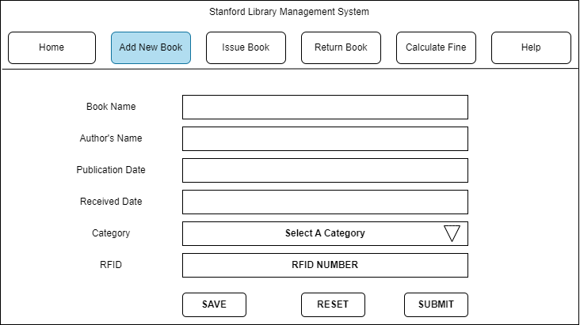

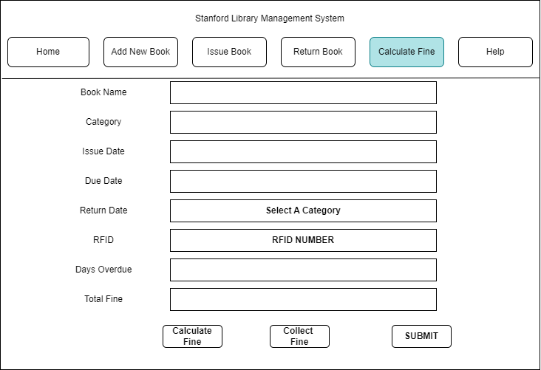

**ER DIAGRAM FOR THE SOFTWARE**

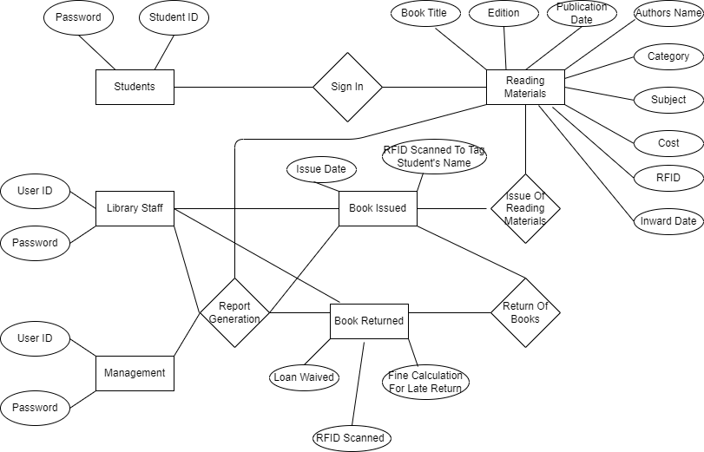

**FUNCTIONAL REQUIREMENTS**

* FR-1: Access to LMS via web interface or mobile.
* FR-2: Should be RFID ready. By scanning the RFID different details like Reading materials name, Author’s name, Publication name, edition, cost, purchase date, category, subject of the reading material can be fetched. Also reading materials can be issues by scanning RFID and also borrower’s name will be tagged in the system.
* FR-3: There will be RFID enables deposit box for books where students can return their books anytime and the loan will be waived off immediately.
* FR-4: Student can access to free e-books, journals, newspaper via internet.
* FR-4: Automated fine calculation for late deposit.
* FR-5: Category wise and subject wise division of reading materials.
* FR-5: LMS will capture and store all the data like – issue date and return date, total number of reading materials available at point of time, stolen books, damaged books, and fine collection of any period of time.
* FR-6: All the books will have RFID tag and at the exit gate there will RFID scanner for theft prevention.
* FR-7: Automated tasks like sending reminder mail to students 3 days prior to the return date.
* FR-8: Report generation like – Which books are getting rented more, aging of the books so that the updated edition can be purchased.

**NON-FUNCTIONAL REQUIREMENTS**

**System Requirement:**

1. LMS will be able to run in windows and Mac OS.
2. Active internet connection will be required to access the LMS.
3. LMS should be RFID ready (NCIP 2.0 HTTP server available)
4. LMS can schedule tasks like sending reminder mail 3 days prior of return date.
5. The data will be stored in cloud.
6. The system will be fast, scalable and secure.

**Usability:** The screen will be self-explanatory and user friendly and there will be a FAQ section.

**Environments:** The LMS will be built and maintained in Java as it will not change much over time, low maintenance.